**Sample Paper- 2013**

**Subject: PHYSICS**

**Class 12th**

M.M 70 TIME: 3 Hours

General Instructions:

1. All questions are compulsory.
2. There are 29 questions in total. Questions 1 to 8 are very short answer type and carry one mark each.
3. Questions 9 to 16 are carry **two** marks each. Questions 17 to 25 are carry **three** marks each. Question 26 is value based question of **four** marks. Questions 27to 29 are carry **five** marks each.
4. There is no overall choice. However, an internal choice has been provided in **one** question of **two** marks, **one** question of **three** marks and all **three** questions of **five** marks each. You have to attempt only one of the given choices in such question.
5. Use of calculator is not permitted. However, you may use log tables if necessary.
6. You may use the following values of physical constants wherever necessary:



1. For long distance radio broadcasting, we use short wave band only, why?
2. Draw the wave front coming out of the convex lens when a plane wave front of light incident on it.
3. Write two energy losses in a Transformer.
4. What should be the length of the dipole antenna for a carrier wave of frequency 3 x 108Hz?
5. Two wires A and B are of same metal and of same length have their areas of cross section in the ratio 2:1. If the same potential difference is applied across each wire in turn, what will be the ratio of current flowing in A and B?
6. What is the effect on the following on inserting a dielectric in a parallel plate capacitor:

(a) Capacitance (b) Charge on the plates of the capacitor

1. A carbon resistor is marked with yellow violet and red color strips. What is its resistance?
2. Why does metallic piece become very hot when it is surrounded by a coil carrying high frequency alternating current?
3. State laws which are used for calculating equivalent resistance of unbalanced wheat stone bridge.
4. How much current is drawn by primary coil of a transformer which steps down 220V to 22Vto operate device with an impedance of 220 ohm?
5. Draw a plot showing the variation of power of a lens with the wavelength of incident light.
6. The threshold frequency of a metal if ‘F0’, when the light of frequency ‘2 F0’ is incident on the metal plate, the maximum velocity of the electron emitted is V1, when the frequency of incident radiation is increased to ‘5 F0’, the maximum velocity of electron emitted is V2. Find the ratio of V1 and V2.
7. The output of a two input NOR gate is fed as input to a NOT gate. Write down the truth table for final output of the combination. OR

Identified the logic gate marked P and Q in the given logic circuit given below. Write down the output at X for the input (i) A=0, B=0 (ii) A=1 and B=1.

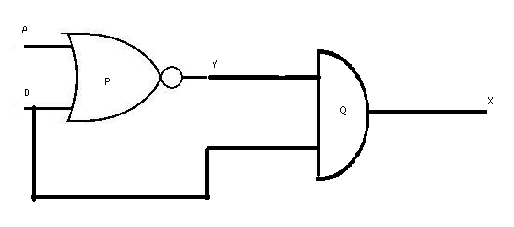

1. What is the effect on (i) Photoelectric current (ii) Stopping potential, if we use red light in place of blue light in case of photoelectric effect?
2. Apply Gauss’ law to obtain an expression for electric field intensity at a point due spherical sheel.
3. 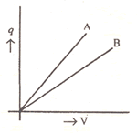The given graph shows the variation of charge q versus potential difference V for two capacitors. The two capacitors C1 and C2 have same plate separation but the plate area of C2 is double than that of C1. Which of the lines in the graph correspond to C1 and C2 and why?
4. The diagram given below, represent the block diagram of a generalized communication system. Identified the element, labeled as X, Y, and Z, in this diagram. Explain the function of each of these elements.

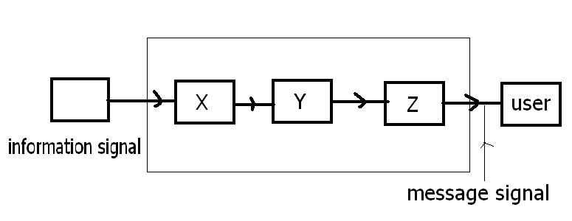

1. (a) Define the term 1. Mass defect 2. Binding energy for a nucleus and state the variation between the two. (b) For a given nuclear reaction the B.E/ nucleon of product nucleus/nuclei is more than that for original nucleus/nuclei. Is this nuclear reaction exothermic or endothermic in nature? Justify your choice. OR

A radioactive isotope has a half life of T years. How long will it take the activity to reduce to 1 % of its original value?

1. Define the term’ electric dipole moment’. Is it scalar or vector? Deduce an expression for electric field at the point on the equatorial plane of an electric dipole of length 2a.
2. The energy levels in an atom of an element are shown in the following diagram.

Which one of the level transition will result in the emission of photon of wavelength 620nm? Support your answer with mathematical calculation.

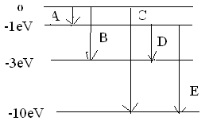

1. (a) Does every charge give out electromagnetic waves? Explain very briefly

(b)The magnetic field in a plane EM wave is given by

By = 2 × 10 -7 sin (0.5 × 103 z + 1.5 × 1011 t) T.

What is the frequency of the wave?

Write an expression for the electric field.

1. Draw course of rays through a compound microscope. Also write the equation for magnifying power?
2. Give a situation where terminal potential difference is greater than emf. Also define internal resistance of the cell and derive an expression for it.
3. State Lenz’s law. Predict the direction of induced current in the situations described by the following Figs.



1. A convex lens made of a material of refractive index n1 is kept in a medium of refractive index n2. Parallel rays of light are incident in the lens. Complete the path of the rays of light emerging from the convex lens if : (1) **n1> n2** (2**) n1= n2** (3) **n1< n2.**
2. Thushar was using a galvanometer in the practical class; unfortunately it fell from his hand and broke. He was upset, some of his friend advised him not to tell the teacher but Thushar decided to tell his teacher. Teacher listened to him patiently and on knowing that the act was not intentional, but just an accident, did not scold him and used the opportunity to show the internal structure of galvanometer to the whole class. (a) What are the values displayed by Thushar. (b) Explain the principle, construction and working of moving coil galvanometer.
3. (a) Explain the term ‘capacitive reactance’. Show graphically the variation of capacitive reactance with frequency of applied alternating voltage. (b.) An AC voltage E= Eo sinωt is applied across a pure capacitor of capacitance . Show mathematically that the current flowing through it leads the applied voltage by a phase angle of $\frac{π}{2}$.

OR What do you mean by resonance of the series LCR circuit? Derive the expression for resonance frequency of Series LCR circuit. Draw the variation of current and frequency of series LCR circuit and explain how it explains the Quality factor.

1. Show by a diagram the image formation of a point object by a double convex lens having radii of curvature R1 and R2.hence derive the formula

http://scienceworld.wolfram.com/physics/limg196.gif

Where, f is the focal length and n is refractive index of material of the lens.

**OR**

Define the term wave front. Draw the wave front and corresponding rays in the case of a (1) plane wave front (2) diverging spherical wave front. Using Hygen’s construction of wave front, explain the refraction of a plane wave front at a plane surface and hence verify the Snell’s law.

1. Define the term ‘depletion layer and barrier potential for a P-N junction diode. How does an increase in the doping concentration affect the width of depletion region? Draw the circuit of a full wave rectifier. Explain its working. OR

Why the base region of transistor is kept thin and lightly doped. Draw the circuit diagram of the set-up used to study characteristics of a npn transistor in its common emitter configuration. Sketch the typical (i.)Input characteristics (ii) output for characteristics this transistor.

---------------------

ARVIND KUMAR

PGT PHYSICS

JNV DODA

(J&K)